The goal of this tool is to implement the ability for a user to view the contents of the shopping cart from any screen within Streamline. Also at a quick glance be able to see the total of the shopping cart.

This is the view of the application in the top right of the header.

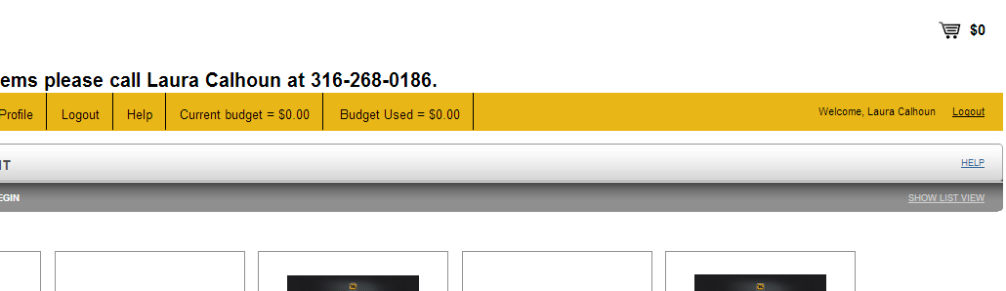

On hover, this is the view:

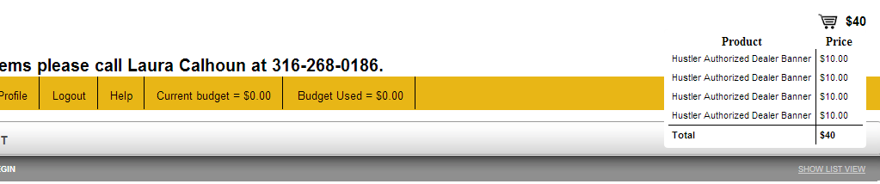

On Click, it will take the user to the shopping cart.